**MS SQL Hands on Exercise**

**Name: Aniroop Gupta**

1. Adding Subtotals Using ROLLUP  
     
   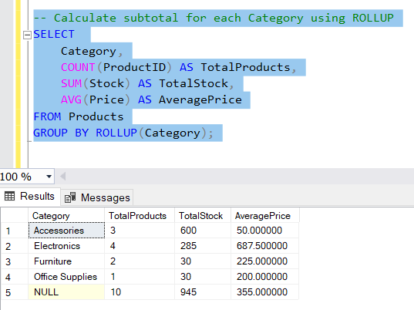
2. Procedure to Insert a New Product

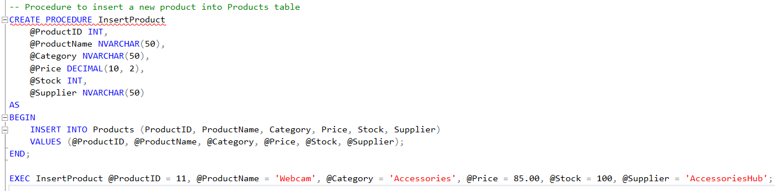

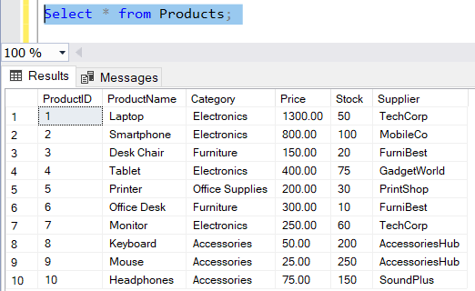

1. Procedure to Update Product Stock

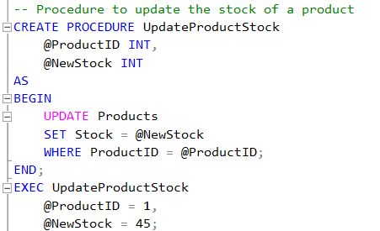

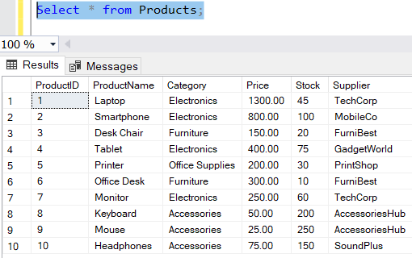

1. Procedure to Retrieve Products by Category with Subtotal

